MATHEMATICS METHODS

MAWA Semester 1 (Unit 3) Examination 2020
Calculator-assumed

Marking Key

© MAWA, 2020
Licence Agreement
This examination is Copyright but may be freely used within the school that purchases this licence.
- The items that are contained in this examination are to be used solely in the school for which they are purchased.
- They are not to be shared in any manner with a school which has not purchased their own licence.
- The items and the solutions/marking keys are to be kept confidentially and not copied or made available to anyone who is not a teacher at the school. Teachers may give feedback to students in the form of showing them how the work is marked but students are not to retain a copy of the paper or marking guide until the agreed release date stipulated in the purchasing agreement/licence.

The release date for this exam and marking scheme is
- June 12th the end of week 7 of term 2, 2020

Section One: Calculator-assumed (100 Marks)

Question 8(a) (3 marks)
Solution
Mathematical behaviours | Marks
- uses initial condition to construct equation and solves for A  - constructs equation related to half life  - solves for $k$ | 1  1  1

Question 8(b) (2 marks)
Solution
For isotope B, .
Solving
Hence approximately 137 years from now.
Mathematical behaviours | Marks
- states equation to be solved  - solves for t and states time (in years) | 1  1

Question 9(a) (2 marks)
Solution
as required.
Mathematical behaviours | Marks
- anti-differentiates the derivative function correctly  - uses the initial condition to find the constant of integration and deduces the required solution | 1  1

Question 9(b) (4 marks)
Solution
(i)
As i.e. population of infected people increases indefinitely
(ii)
As i.e. population of infected people stabilises to 25
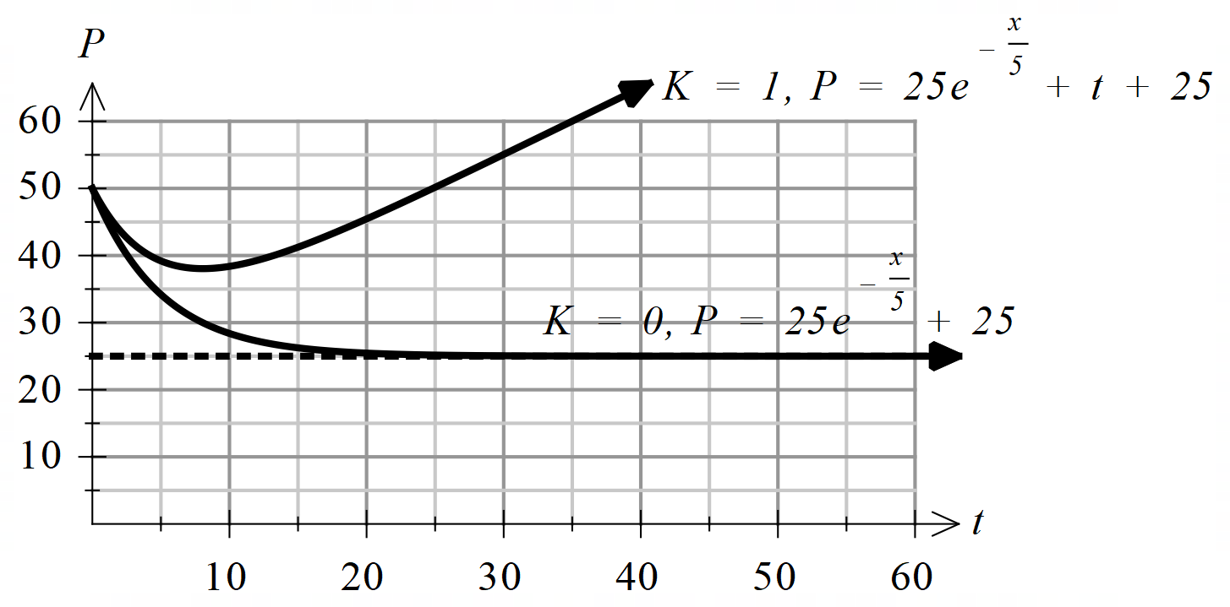(iii)

Mathematical behaviours | Marks
(i)  - recognises that when K = 1, and as  ie population of infected people increases indefinitely  (ii)  - recognises that when K = 0 and as  ie population of infected people stabilises to 25  (iii)  - correct graph for K= 0  - correct graph for K = 1 | 1  1  1  1

Question 9(c) (3 marks)
Solution
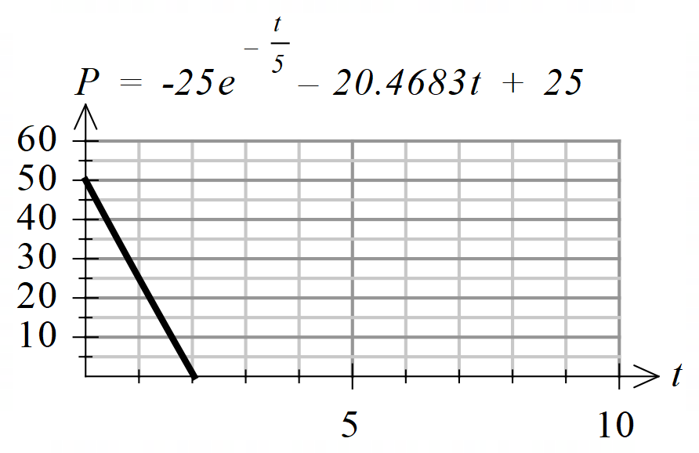
Hence,
From CAS, this is a decreasing function.
ie Population of infected people will reduce to zero after 2.0345 weeks
Mathematical behaviours | Marks
- uses t = 1 and P = 25 to find the correct value of K  - uses P = 0 to find the value of t  - states a valid prediction | 1  1  1

Question 10(a) (3 marks)
Solution
Area of triangle
Hence,
Mathematical behaviours | Marks
- determines area of triangle as an exact value  - states formula for total area in terms of x  - clearly demonstrates rearrangement of formulae to achieve required  result. | 1  1  1

Question 10(b) (3 marks)
Solution
Hence the maximum area is approximately 5.86 m².
Mathematical behaviours | Marks
- equates to 0 and solves  - determines or otherwise justifies maximum  - calculates maximum area | 1  1  1

Question 11(a) (4 marks)
Solution
Mathematical behaviours | Marks
- equates the sum of probabilities to 1  - evaluates b  - states expression for  - evaluates a | 1  1  1  1

Question 11(b) (5 marks)
Solution
(i)
(ii)
Standard deviation of standard deviation of
Mathematical behaviours | Marks
(i)  - states expression to determine the variance of X  - evaluates variance  - evaluates standard deviation  (ii)  - states correct result | 1  1  1  1

Question 12(a) (2 marks)
Solution
$$h$$ | $$a$$ | $$\frac{a^{h}-1}{h}$$
$$0.1$$ | $$2$$ | $$0.7177$$
$$0.01$$ | $$2$$ | $$0.6956$$
$$0.001$$ | $$2$$ | $$0.6934$$
$$0.0001$$ | $$2$$ | $$0.6932$$

Mathematical behaviours | Marks
- completes two rows of the table correctly  - completes all rows of the table correctly | 1  1

Question 12(b) (1 mark)
Solution
$\lim_{h→0}{\frac{2^{h}-1}{h}=0.693,}$correct to $3$ decimal places.
Mathematical behaviours | Marks
- evaluates limit correctly | 1

Question 12(c) (2 marks)
Solution
(i)
(ii)
Mathematical behaviours | Marks
(i)  - states solution  (ii)  - states exact solution | 1  1

Question 13(a) (1 mark)
Solution
x | 1 | 2 | 3 | 4
y | 2

Mathematical | Marks
- states all three correct values | 1

Question 13(b) (4 marks)
Solution
(i)
Area of lower rectangles

(ii)
Area of upper rectangles

Mathematical behaviours | Marks
(i)  - sums the correct rectangles  - deduces correct result  (ii)  - sums the correct rectangles  - evaluates correctly | 1  1  1  1

Question 13(c) (1 mark)
Solution
Estimated area

Mathematical behaviours | Marks
- calculates the average of the lower and upper areas | 1

Solution
Area under the curve is
Mathematical behaviours | Marks
- states the correct answer | 1
Question 13(d) (1 mark)

Question 14(a) (1 mark)
Solution
Some people would read both digital and print. If these entries are summed those people will be counted twice.
Mathematical behaviours | Marks
- recognises that some people will read both forms of publication | 1

Question 14(b) (2 marks)
Solution
Mathematical behaviours | Marks
- uses correct numerator  - uses correct denominator and deduces result | 1  1

Question 14(c) (3 marks)
Solution
Mathematical behaviours | Marks
- states Binomial  - calculates mean  - calculates variance | 1  1  1

Question 14(d) (5 marks)
Solution
(i)
(ii)
(iii)
Mathematical behaviours | Marks
(i)  - states correct probability  (ii)  - states appropriate probability expression  - calculates probability  (iii)  - states correct expression for first three outcomes  - states fourth outcome and calculates probability | 1  1  1  1  1

Question 14(e) (3 marks)
Solution
Let be the random variable denoting the number of people in the 200 who read print media.
Mathematical behaviours | Marks
- changes parameter of distribution  - states appropriate probability statement  - evaluates | 1  1  1

Question 15(a) (2 marks)
Solution
Mathematical behaviours | Marks
- applies linearity for derivatives  - applies the Fundamental Theorem and evaluates, stating the correct result | 1  1

Question 15(b) (2 marks)
Solution
Mathematical behaviours | Marks
- differentiates both sides of the equation (or applies result from part (a))  - determines result | 1  1

Question 16(a) (1 mark)
Solution
Mathematical behaviours | Marks
- states correct answer | 1

Question 16(b) (1 mark)
Solution
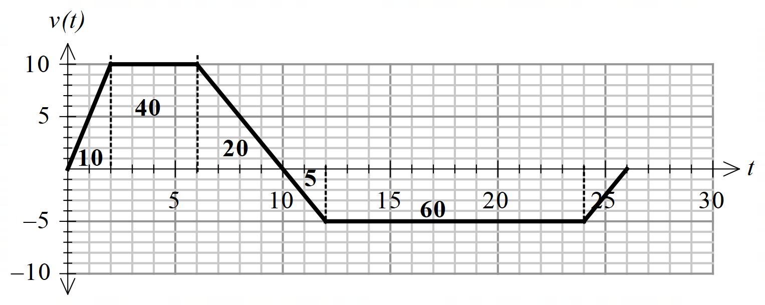

Distance travelled in the first 6 seconds is 50 metres
Mathematical behaviours | Marks
- states correct answer | 1

Question 16(c) (1 mark)
Solution
Displacement after 12 seconds is 65 m
Mathematical behaviours | Marks
- states correct answer | 1

Question 16(d) (1 mark)
Solution
Distance travelled after 12 seconds is 10+40+20+5 =75 m
Mathematical behaviours | Marks
- states correct answer | 1

Question 16(e) (1 mark)
Solution
At both the velocity and the acceleration are negative hence the particle is speeding up.
Mathematical behaviours | Marks
- states the particle is speeding up | 1

Question 17(a) (2 marks)
Solution
y | 0 | 1
P(Y=y)

Mathematical behaviours | Mark
- completes first probability correctly  - completes second probability correctly | 1  1

Question 17(b) (2 marks)
Solution
It is a Bernoulli distribution with mean =
Mathematical behaviours | Marks
- states the distribution name  - states the mean | 1  1

Question 17(c) (2 marks)
Solution
or 2
Mathematical behaviours | Marks
- states all values | 1

Question 17(d) (1 mark)
Solution
(not prime and not prime)
Mathematical behaviours | Mark
- calculates probability | 1

Question 17(e) (3 marks)
Solution
Hence X=1 is the most likely result.
Mathematical behaviours | Mark
- calculates  - calculates  - states correct conclusion | 1  1  1

Question 17(f) (3 marks)
Solution
Let the random variable represent the operator’s financial position for each game.
f | -2 | 5

Hence the operator will expect to make a profit of $1.36 per game in the long term. With 500 contestants he will expect to make
Mathematical behaviours | Marks
- determines expected value for 1 game  - calculates gain for the day  - states final outcome, with unit and explains | 1  1  1

Question 17(g) (2 marks)
Solution
Let be the charge to play the game.
f | (k-7) | k

Hence the operator would need to charge $3.64.
Mathematical behaviours | Marks
- constructs equation for expected value  - solves equation to determine | 1  1

Question 18(a) (6 marks)
Solution
(i)
Since the maximum and minimum values are 14.5 and 9.5
and and
or
mean line and amplitude
Since the period of the oscillation is 12,
(ii)
Maximum at t = 11.7
Mathematical behaviours | Marks
(i)  - explains exactly one of a and b values  - explains both a and b values  - identifies the period to explain the value of c  (ii)  - differentiates correctly  - equates to 0 and equates angle to  - solves equation to determine d | 1  1  1  1  1  1

Question 18(b) (1 mark)
Solution
On April 30th,
hours
So we can expect $10.4$ hours of sunlight on April 30th.
Mathematical behaviours | Marks
- states correct answer | 1

Question 18(c) (2 marks)
Solution
So average =

So the average daily amount in May and June is $9.77$ hours
Mathematical behaviours | Marks
- uses correct integral  - states solution | 1  1

Question 18(d) (3 marks)
Solution
Hence the maximum value of is hours per month
Using the increments formula , the maximum change in successive days is approximately hours.
i.e. 2.62 minutes (or $3$ minutes to the nearest minute).
Mathematical behaviours | Marks
- identifies maximum value of $\frac{dS}{dt}$  - substitutes into increments formula correctly  - states answer to the nearest minute | 1  1  1

Question 19(a) (3 marks)
Solution
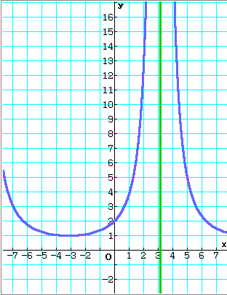
represents the area bounded by the curve,
the line and the line
The function is undefined at since hence the
area cannot be calculated
Mathematical behaviours | Marks
- relates the integral to an area under the curve  - states that since is undefined at  - concludes that the area cannot be calculated – it id not bounded | 1  1  1

Question 19(b) (5 marks)
Solution
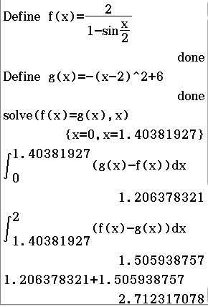
Mathematical behaviours | Marks
- determines point of intersection of and  - states appropriate integral to determine first area  - states appropriate integral to determine second area  - evaluates one integral correctly  - determines correct result to two decimal places | 1  1  1  1  1

Question 19(c) (3 marks)
Solution
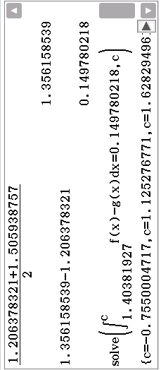
Hence
Hence
Mathematical behaviours | Marks
- determines average of two areas  - states appropriate equation to be solved involving integral  - solves equation and concludes solution | 1  1  1

